Name: | ___________________________________________________ |  |  | Date: ___________
 | Methods Unit 1  Test 1, 2015  Topics – Equations, Polynomials and Conditional Probability |  |  | 45  = %
Total Time: | 45 minutes
Weighting: | 3.5% of the year.
Equipment: | SCSA Formula Sheet; ½ page notes (A4 one side), CAS calculator; Scientific Calculator
SECTION 1: CALCULATOR FREE
Time: | 25 minutes | Marks for Section 1: | 24 marks
 |  | Equipment Allowed: | Nil

1. | [1 mark: 1]
 | A bag of 20 apples has 4 rotten ones in it. If the first two apples taken at random from the bag are good, what is the probability that the next one will be rotten?

2. | [1 mark: 1]
 | The probability that a card drawn from a normal pack (52 cards) is a club or an Ace is:

3. | [2 marks: 2]
 | A 420-page novel is opened to a random page by 3 different students. What is the probability that they all open it to a page number between 1 and 105?

4. | [6 marks: 3, 3]
 | Solve the following simultaneous equations
a) | 5c +y = 10 and c + y = 10
b) | a – 6b = -6 and a – 2b = 2

5. | [8 marks: 2, 3, 3]
 | Solve the following equations
a) | (3x – 2)(x + 9) = 0
b) | x² – 5x – 14 = 0
b) | 3x2 – 5x – 12 = 0

6. | [2 mark: 2]
 | Given that y is inversely proportional to the square root of x, and that y = 24 when x = 36, find the value of x when y = 96.

7. | [4 marks: 1, 1, 1, 1]
The numbers of boys and girls doing some optional subjects on at the same time (on the same
line of the timetable) in Year 11 at a school are shown here.
 | Theatre | Workshop | Computer skills | History
Boys | 13 | 28 | 32 | 19
Girls | 34 | 7 | 35 | 13

a) | Given that a student is taking Theatre, what is the probability that the student is female?
b) | Given that a student is female, what is the probability that she is doing theatre?
c) | What is the probability that a student selected at random is a girl taking theatre?
d) | What is the probability that a boy on this line is in a workshop class?

~ END OF SECTION 1 ~

Name: | ___________________________________________________ |  | Date: ___________
SECTION 2: CALCULATOR ASSUMED
Time: 20 minutes |  | Equipment Allowed: Curriculum Council Formula sheets,  CAS calculator, 1 page of notes (A4 one side)
Marks for Section 2: 21 marks

8. | [3 marks: 1, 1, 1]
 | Graph each equation then solve graphically.
a) | x² – 5x – 2 =  

9. | [4 marks: 4]
Mike had a pen with chickens and rabbits in it. Between them, the animals had 42 heads and 142 feet.
Write equations and solve them to find out how many chickens and how many rabbits there were in the pen.

10. | [5 mark: 5]
 | A Wilderness Trekking tour operator offers complete packages to the Tasmanian World Heritage areas from Launceston. The cycling tours may be from 3 to 12 days in length. They cost $780 for the 3-day tour and $180 for each additional day.
a) | Draw a graph showing the cost of the cycling tours.
b) | Find a relationship between the number of days and the cost of the tours.

11. | [3 marks: 1, 1, 1]  For the following graphs, match each with the correct discriminant
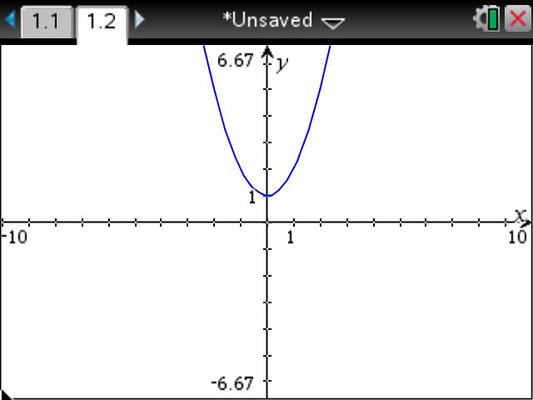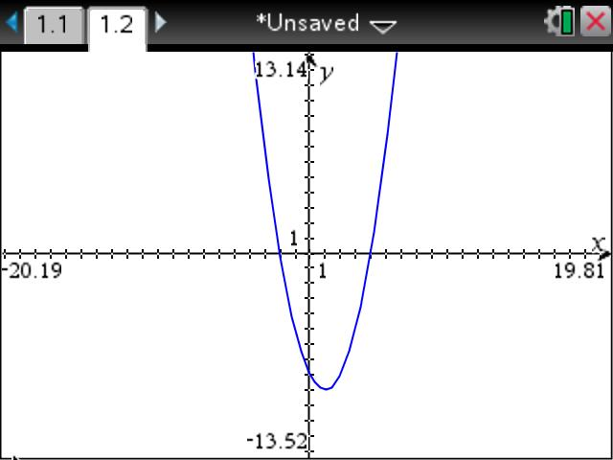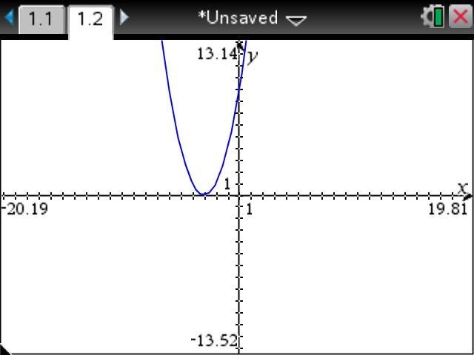
A B C

i) 0____________________ ii) -3____________________ iii) 6 ____________________

12. | [6 marks: 6]
Divide the polynomial P(x) = 2x3 + 4x2 – x + 1 by x – 3 and hence write P(x) in the form
P(x) = (x – 3)Q(x) + R.

~ END OF TEST ~

